
ACTIVE LEARNING TEMPLATE: Growth and Development

STUDENT NAME

DEVELOPMENTAL STAGE TODDLER REVIEW MODULE CHAPTER

EXPECTED GROWTH AND DEVELOPMENT


Physical |  |  | Cognitive
Development |  |  | Development
There is increased |  |  | The baby is
rapid physical |  |  | developing abilities
growth between ages |  |  | to think remember
1-2.The growth |  |  | and learn at a very
slows down between |  |  | quick pace. The baby
ages 2-5 while |  |  | should be engaged in
toddler develops |  |  | activities that support
strength and |  |  | this development. (Hills, 2007)
coordination.
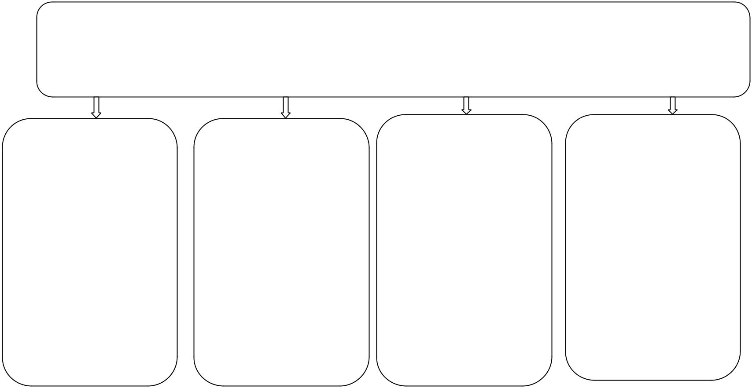

Health promotion

Psychological
Development

The baby first forms of communication are via sound and facial expressions. The baby will cry to signal uncomfortable will smile to respond to pleasure.

Age- Appropriate Activities

The activities that are

appropriate are the

once that

encouraging the

toddlers movement

coordination. Walk

together with toddler

and play active

games.

At this stage the baby constantly require clinical care. The problems involved may include temper tantrums, constipation and toilet training among others.

Immunizations |  | Health Screening
The common |  | The toddler
vaccines include |  | screening should be
whooping cough,
 |  | constant in which
tetanus, and rotavirus
 |  | conditions such as
among others. The
 |  | tuberculosis,
schedule
 |  | cholesterol and
recommended by
CDC should be |  | pneumonia are
followed. |  | checked and the
 |  | blood pressure
 |  | monitored Nutrition.

Nutrition |  | Injury Prevention
The toddler needs |  | Toddlers should be
regular times with |  | prevented from
realistic portion. |  | consuming
Encourage toddlers |  | something
to eat whole fruits |  | dangerous. They
and serve dessert |  | should be checked
with the whole meal  (Snider, 2007). |  | constantly while
 |  | playing in secured
 |  | zones.

ACTIVE LEARNING TEMPLATES THERAPEUTIC PROCEDURE A5

